Overview

This document discusses the installation of Mosaic OA using Microsoft’s SMS application. This particular process involves the undocumented silent mode for InstallShield, version 3.00.118.0. InstallShield version 5 has fully documented silent mode installation instructions.

NOTE: The silent install file may need to be modified for a particular sites configuration.

Release levels
Fap3 3.1.4
RT 1.4.12
CDS 1.4.12
InstallShield 3.00.118.0
SMS 1.2
SQL 6.5

Overview
The deployment of Mosaic OA and other components with SMS is a four-step process:

Step 1:
Place the install image on the SMS server.

Step 2:
Install the package on the server with the –r (record) switch.

Step 3:
Create an SMS package using the install image.

Step 4:
Create an SMS job and distribute and install the components using the recorded instruction file (setup –s).

STEP 1 Place the install image on the SMS server

- On the SMS server, find where SMS is installed (i.e. d:\sms - the SMS share SMS_SHRD).
- Create a holding directory (i.e. d:\sms\InstallImages).
- Inside the holding directory create a directory for each image (i.e. Fap314, Rt1412, CDS1412).
- Copy the install image (from the CD) to each image directory.

STEP 2 Install the package and record the process

- Run the setup program with the -r option (i.e. setup.exe –r).
- As the installation takes place, answer the questions and prompts the same way you want the workstations to be installed.
- When the installation completes, the SMS server will have the actual application installed. In the WINNT directory there will be an install.iss file. Move this file back into the image directory where setup was run from. This is the silent install file that will be used in the next steps.

NOTE: The CDS installation will copy files to the proper places and then start the svrcfg program. Because this program runs outside of the InstallShield record process, the prompts that it makes are not part of the recording and will have to be answered separately when the actual installation process takes place.
STEP 3 Create an SMS package using the install image

- On the SMS server, start SMS.
(Task bar -> Start -> Programs -> System Management Server -> SMS Administrator)
- You’ll be asked for the SQL login (see figure 2.1).
(enter the SQL Server Name, Database, Login ID, and Password)

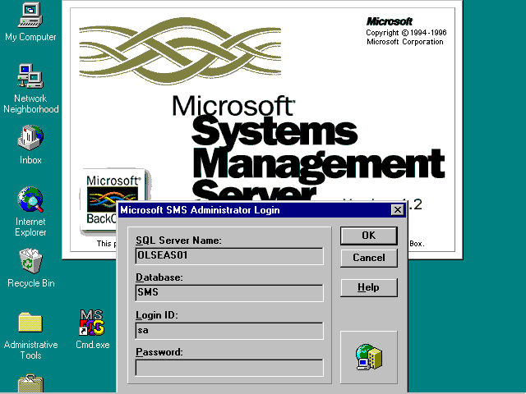
Figure 2.1
- Open the SMS packages window (see figure 2.2).
(SMS Admin – Menu bar -> File -> Open -> Packages)

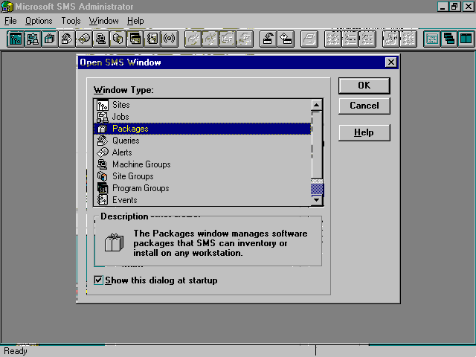
Figure 2.2
- From the packages window (see figure 2.3), create a new package (figure 2.4).
(SMS Admin – Menu bar -> File -> New)

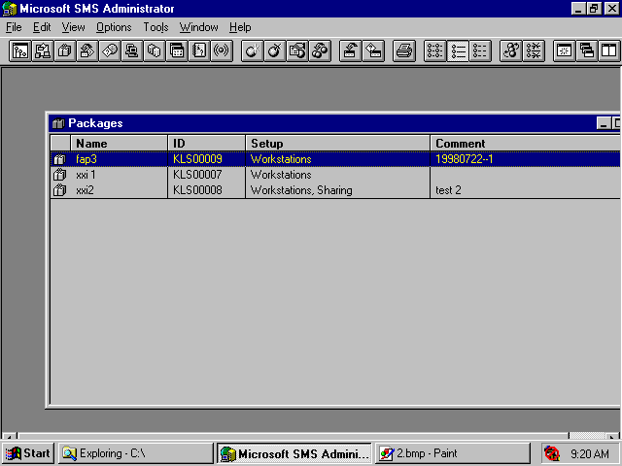
Figure 2.3
- Enter a package name (i.e. Fap314) and a descriptive comment and the select the “Workstation” button to start the package setup (see figure 2.5).

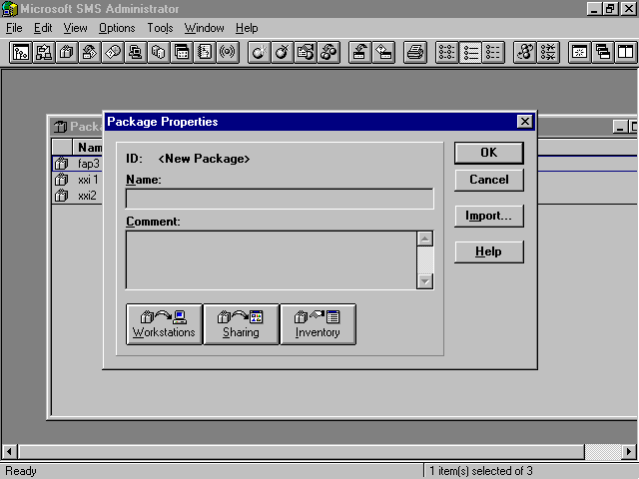
Figure 2.4
- Browse for the source directory and find the image directory you created in step 1.C. Next select the “New” button to go to the Workstation Command Line Properties (see figure 2.6)

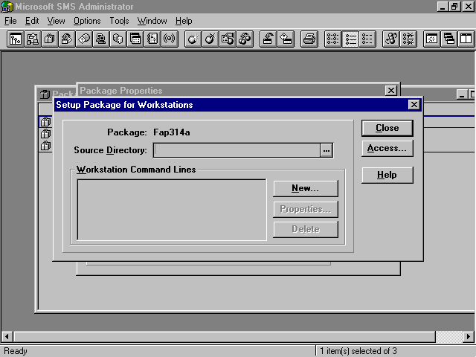
Figure 2.5

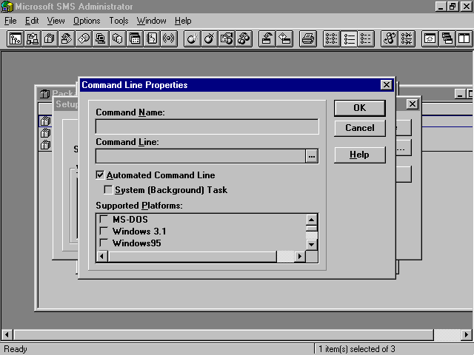
Figure 2.6

- On the command line properties box, (see figure 2.7)
- Enter any name into the “Command Name” (i.e. Install).
- In the “Command line” text box, browse to find the “setup.exe” file.
Modify this line to look like this “setup.exe –s –SMS” (InstallShield silent install on SMS).
- Check mark the platform under “Supported Platforms” (i.e. Windows NT (x86)).

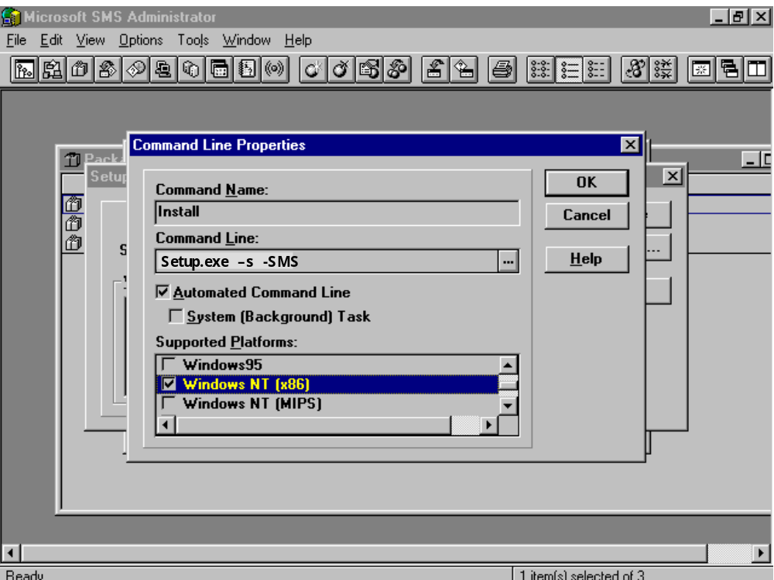
Figure 2.7
- Select “OK” and “Close” to exit.
You’ll get a warning message box stating that the package directory may not be accessible to other SMS components, select “OK”.
- Select “OK” to exit the “Package Properties” box.
You’ll get a message box stating that SMS will update this package on other SMS servers, select “OK”.
- The package window will now have your new package (see figure 2.8).
NOTE: The ID for this package. If the package is large, then it may take several minutes for SMS to build the package (check the package area (i.e. d:\Sms_pkgd)).

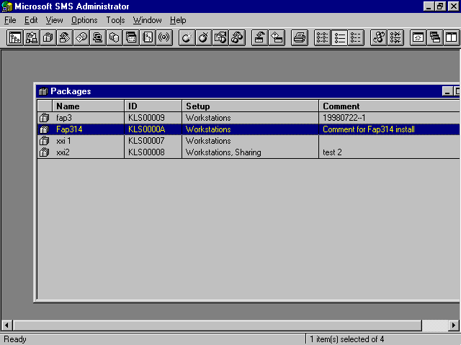
Figure 2.8

STEP 4 Create an SMS job

- Go to SMS jobs (see figure 3.1).
(SMS Admin – Menu bar -> File -> Open -> Jobs)

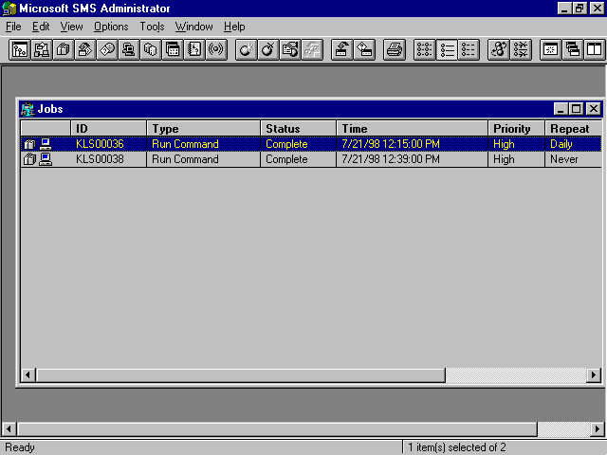
Figure 3.1

- From the jobs window (see figure 3.1), go to a new job properties box (figure 3.2) and enter a comment.
(SMS Admin – Menu bar -> File -> New)

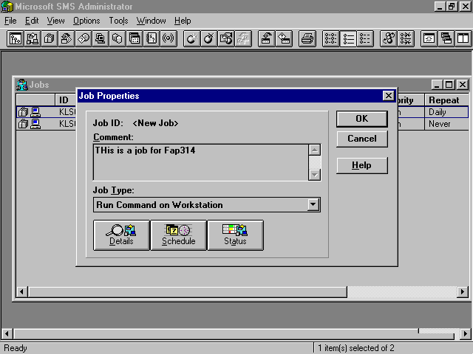
Figure 3.2

- Select the “Detail” button to go to “Job Details” window (see figure 3.3).
- Select the correct “Package”.
- Select the correct “Run Workstation Command”.

To have this job run sooner:
- Select “Even if Previously Sent”.
- Decrease the “Offer After” by a day.

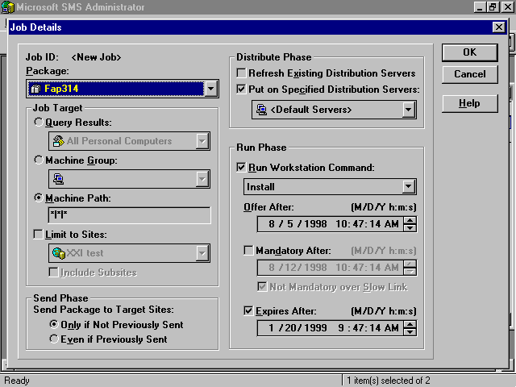
Figure 3.3

- Select “OK” and “OK” to exit back to the jobs list window.

- To monitor a job, select a job (see figure 3.1), select the “Status” button (see figure 3.2),
Select the “Details” button and you’ll see the current status (see figure 3.4).

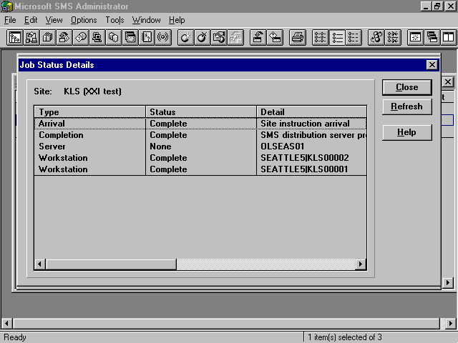
Figure 3.4

